OPERATING SYSTEMS
Project Report

INTERPROCESS COMMUNICATION VIA DIFFERENT MECHANISMS

Group Members:
Syeda Hafsah Awais 17k-3698
Mohammad Wajeeh Zahid 17k-3941
Section:D

Objective:
The aim of this project is to show how different tasks can be performed using various interprocess communication mechanisms like shared memory,message passing,semaphore,sockets and many others.
Description:
In our project we used two different inter-process communication methods, shared memory and message queues. In our project we performed 3 tasks, Sorting, Matrix multiplication and computing Taylor series using both shared memory and message passing. To provide additional functionality we have incorporated threads in our project so that we can compute a larger Matrix and a bigger series.
- Shared Memory Taylor Series
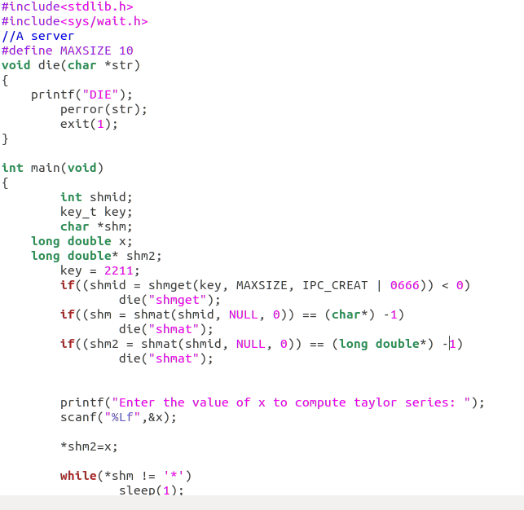

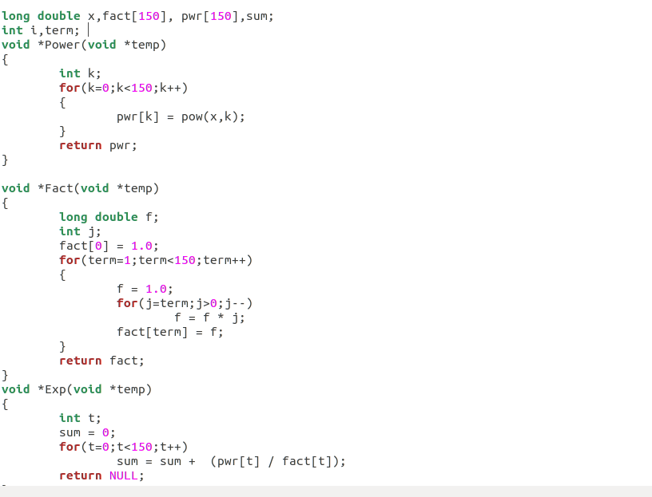

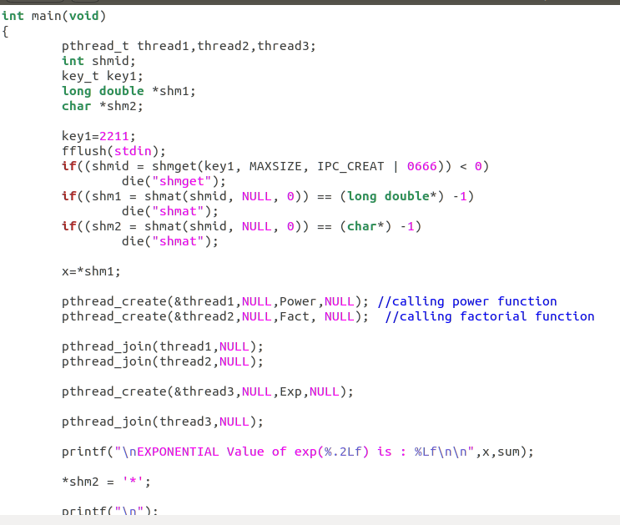

- Shared Memory Sorting
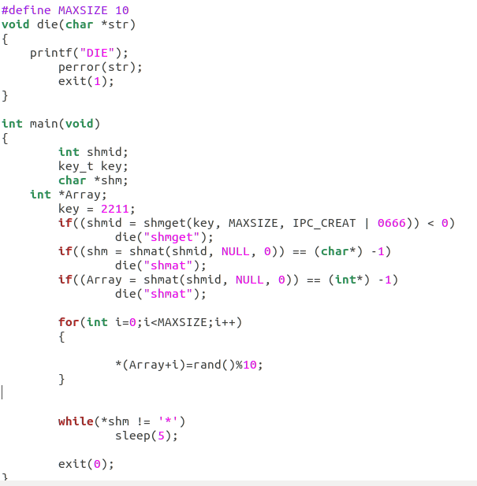

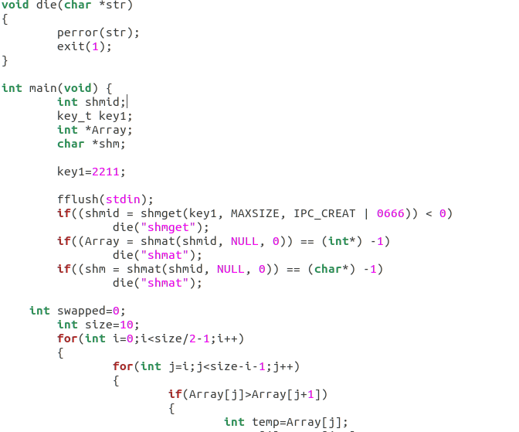

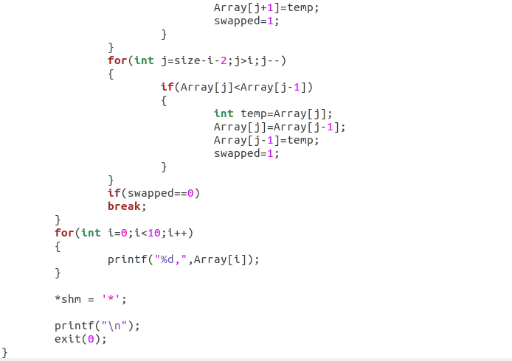
- Matrix Computation Via Message Passing
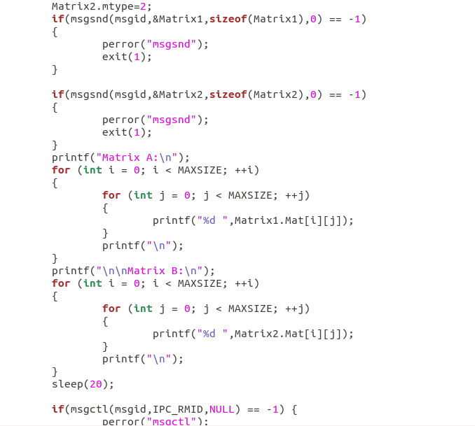
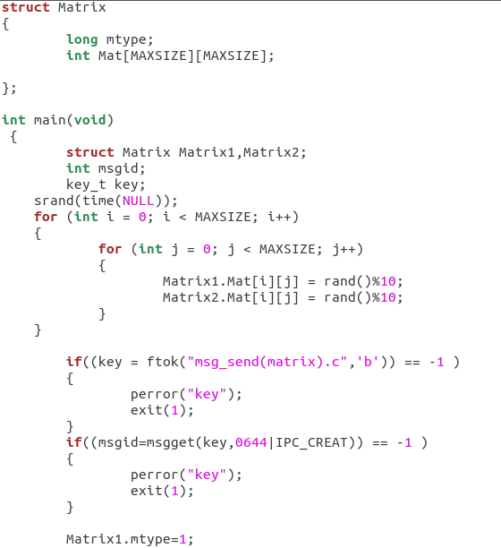
msg rcv
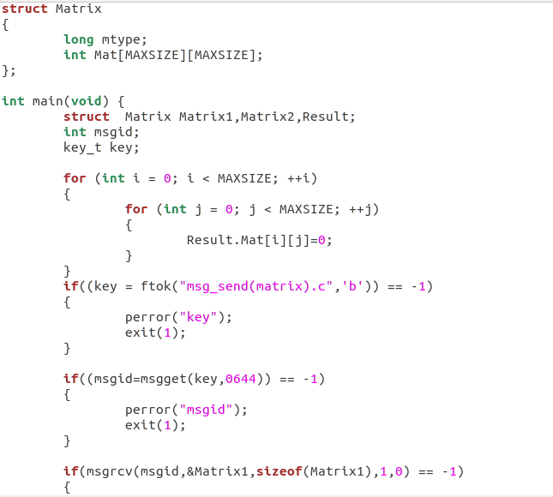
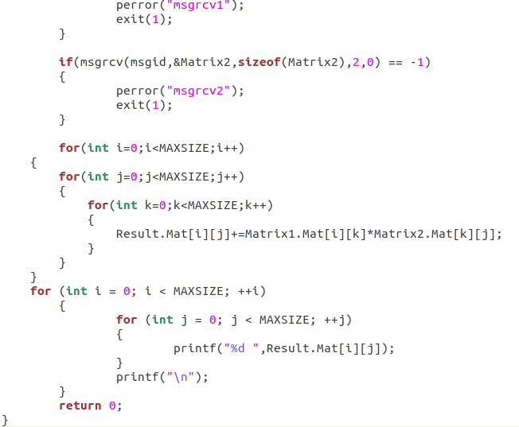
Conclusion:
To conclude,Interprocess communication facilitates efficient message transfer amongst processes and allows data sharing without any interference.

